Name: A.Reddy Sulochana
Reg.No: 192372370

Exp.No.05 Missionaries and Cannibals Problem
01.08.26

Aim:
To implement the Missionaries and Cannibals Problem in Python and find a safe sequence of moves to transfer all missionaries and cannibals across the river.
Algorithm:
- Start the program.
- Represent the state as (Missionaries Left, Cannibals Left, Boat Side).
- Initialize the start state as (3, 3, 'L') and the goal state as (0, 0, 'R').
- Generate all valid boat moves.
- Check that missionaries are never outnumbered by cannibals on either bank.
- Continue exploring valid states until the goal state is reached.
- Display the sequence of safe moves.
- Stop the program.

Program:
from collections import deque
m = int(input("Enter number of Missionaries: "))
c = int(input("Enter number of Cannibals: "))
start = (m, c, 1)
goal = (0, 0, 0)
moves = [(1,0), (2,0), (0,1), (0,2), (1,1)]
def valid(m1, c1):
if m1 < 0 or c1 < 0 or m1 > m or c1 > c:
return False
if m1 > 0 and m1 < c1:
return False
if (m-m1) > 0 and (m-m1) < (c-c1):
return False
return True
queue = deque([(start, [])])
visited = set()
while queue:
(ml, cl, boat), path = queue.popleft()
if (ml, cl, boat) == goal:
print("Solution Path:")
for state in path + [(ml, cl, boat)]:
print(state)
break
if (ml, cl, boat) in visited:
continue
visited.add((ml, cl, boat))
for dm, dc in moves:
if boat == 1:
nm, nc, nb = ml - dm, cl - dc, 0
else:
nm, nc, nb = ml + dm, cl + dc, 1
if valid(nm, nc):
queue.append(((nm, nc, nb), path + [(ml, cl, boat)]))

Input:
Enter number of Missionaries: 3
Enter number of Cannibals: 3
Output:
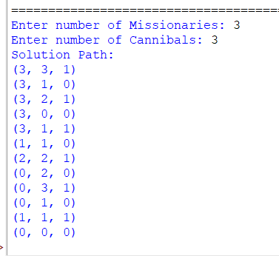

Result:
Thus, the Python program to solve the Missionaries and Cannibals Problem was executed successfully, and a safe sequence of moves was obtained.

